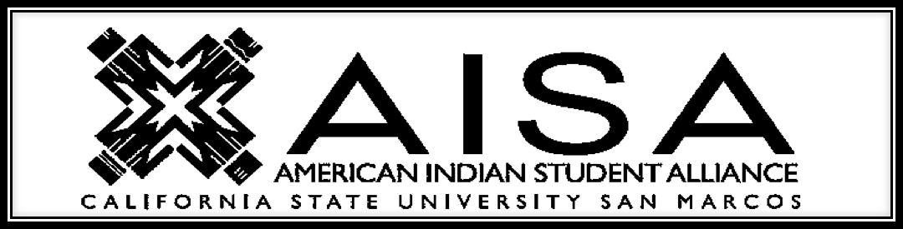

Scheduled Meetings
Tuesdays
12:00pm- 1:00pm

September 10th
September 17th
September 24th
October 1st
October 8th
October 15th
October 22nd
October 29th
November 5th
November 12th
November 19th
November 26th

Location: Social & Behavioral Sciences Building
California Indian Culture and sovereignty Center 
-Conference room 1128

Contacts: Michael Murphy (Co-Chair) murph090@cougars.csusm.edu
Laila Basquez (Co-Chair) basqu001@cougars.csusm.edu
Bethany DeVries (Treasurer) bethanydevries@yahoo.com

